Implementing a GUI for the Gourmet Coffee System (Part II)

Prerequisites, Goals, and Outcomes
Prerequisites: Before you begin this exercise, you need mastery of the following:
- Graphical user interface
  - Knowledge of Swing components and containers
  - Knowledge of Swing event handling
  - Knowledge of JFileChooser dialog
Goals: Reinforce your ability to create a GUI with event handling
Outcomes: You will master the following skills:
- Produce interactive applications that use a Swing GUI

Background
In this assignment, you will create a comprehensive GUI for the Gourmet Coffee System. Part of the work has been done for you and is provided in the student archive. You will implement the code that handles the button events.

Description
Class GourmetCoffeeGUI implements a GUI for the Gourmet Coffee System. This GUI lets the user display the product catalog, process orders, and track the store's sales:
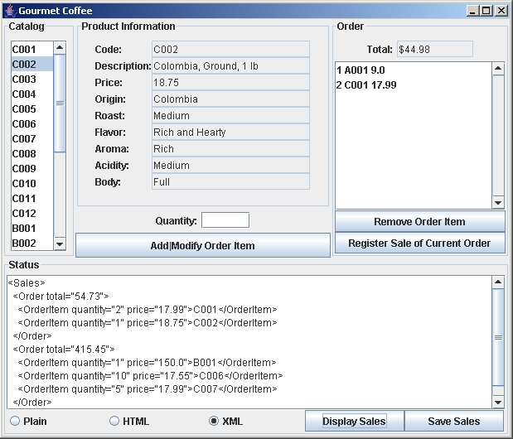
Figure 1 Execution of GourmetCoffeeGUI
The GUI is divided into four panels: Catalog, Product Information, Order, and Status:
- The Catalog panel contains a list of product codes.
- The Product Information panel contains product details. Positioned immediately beneath this panel are a text field to specify the quantity of the selected product and a button to add the selected product to the current order.
- The Order panel contains the current order, its cost, and buttons to edit the order and register its sale.
- The Status panel contains a text area to display messages and sales information; command buttons to display and save sales information; and radio buttons to specify the format of the sales information when it is displayed or saved.
When a user clicks one of the following command buttons, GourmetCoffeeGUI handles the associated event as described below:
- addModifyButton. Adds the selected product to the current order. If the selected product is already part of the order, modifies the quantity of that product in the order.
- removeButton. Removes the selected item from the current order.
- registerSaleButton. Adds the current order to the store's sales and empties the current order.
- displaySalesButton. Lists all orders that have been sold in the specified format (plain text, HTML, or XML).
- saveSalesButton. Saves all orders that have been sold in a file with the specified format (plain text, HTML, or XML).
When a user clicks one of the following radio buttons, GourmetCoffeeGUI handles the associated event as described below:
- plainRadioButton. Changes the format of the sales information to plain text.
- HTMLRadioButton. Changes the format of the sales information to HTML.
- XMLRadioButton. Changes the format of the sales information to XML.
When a user selects an element in the following list, GourmetCoffeeGUI handles the associated event as described below:
- catalogList. Displays the details of the selected product in the "Product Information" panel.
GourmetCoffeeGUI defines the following Swing components:
- catalogList. Displays the product code of every product in the product catalog.
- orderList. Displays the items in the current order.
- quantityTextField. Allows user to specify the quantity of the selected product.
- totalTextField. Displays the total cost of the current order.
- statusTextArea. Displays status messages and sales information.
- fileChooser. A JFileChooser object. Allows user to specify the name and location of the file in which the sales information will be saved. This dialog box appears when the “Save Sales” button is clicked.
GourmetCoffeeGUI defines the following instance variables:
- catalog. Contains the product catalog, a Catalog object.
- currentOrder. An Order object that contains the items to be purchased.
- sales. A Sales object that contains the orders that have been sold.
- salesFormatter. A SalesFormatter object that specifies the format to be used when the sales information is displayed or saved.
- dollarFormatter. A NumberFormat object used to find the dollar representation of a number. (The dollar representation of 1.0 is "$1.00".)
New methods have been added to classes Catalog and Order:
- The method getCodes has been added to the class Catalog. It returns an array of product codes (all the product codes in the product catalog) which is used by GourmetCoffeeGUI to populate the catalog JList.
- The method getItems has been added to the class Order. It returns an array of the OrderItem objects (all the items in the current order) which is used by GourmetCoffeeGUI to populate the order JList.
The button events are handled using named inner classes in class GourmetCoffeeGUI. The following inner classes are complete and should not be modified:
- DisplayProductListener. Listener for the catalog list
- RegisterSaleListener. Listener for the button "Register Sale of Current Order"
- PlainListener. Listener for the radio button "Plain"
- HTMLListener. Listener for the radio button "HTML"
- XMLListener. Listener for the radio button "XML"
- DisplaySalesListener. Listener for button "Display Sales"
In this assignment, you should complete the implementation of the following inner classes:
- AddModifyListener. Listener for button "Add|Modify Order Item"
- RemoveListener. Listener for button "Remove Order Item"
- SaveSalesListener. Listener for button "Save Sales"

Files
The following files are needed to complete this assignment:
- exe-gourmet-coffee-gui.jar. Download this file. It is the sample executable.
- student-files.zip. Download this file. This archive contains the following:
  - Class files
    - Coffee.class
    - CoffeeBrewer.class
    - Product.class
    - Catalog.class. A modified version of class Catalog
    - OrderItem.class
    - Order.class. A modified version of class Order
    - Sales.class
    - CatalogLoader.class
    - FileCatalogLoader.class
    - DataFormatException.class
    - SalesFormatter.class
    - PlainTextSalesFormatter.class
    - HTMLSalesFormatter.class
    - XMLSalesFormatter.class
    - DataField.class
  - Documentation
    - Coffee.html
    - CoffeeBrewer.html
    - Product.html
    - Catalog.html. A modified version of class Catalog
    - OrderItem.html
    - Order.html. A modified version of class Order
    - Sales.html
    - CatalogLoader.html
    - FileCatalogLoader.html
    - DataFormatException.html
    - SalesFormatter.html
    - PlainTextSalesFormatter.html
    - HTMLSalesFormatter.html
    - XMLSalesFormatter.html
    - DataField.html
  - Java files
    - GourmetCoffeeGUI.java. Use this template to complete your implementation.
  - Data files for the test driver
    - catalog.dat. A file with product information for every product in the product catalog

Tasks
Complete the implementation of AddModifyListener, RemoveListener, and SaveSalesListener. The messages displayed in the status area by these inner classes should match the messages displayed by the sample executable.
Follow Sun's code conventions. The following steps will guide you through this assignment. Work incrementally and test each increment. Save often.
- Extract the files by issuing the following command at the command prompt:
C:\>unzip student-files.zip
- Run the sample executable by issuing the following command at the command prompt:
C:\>java -jar exe-gourmet-coffee-gui.jar
Note: This application requires the file catalog.dat which you will find in student-files.zip.
- Then, copy the code of method getDataFieldsPanel that you created in the previous exercise.
- Next, implement method actionPerformed in the inner class AddModifyListener: If the current order does not contain an item with the selected product, then create a new order item and add it to the current order. Otherwise, locate the item in the order with the selected product and changes its quantity to the value specified by the user. Finally, update the current order list (use method Order.getItems to obtain an array containing all the items in this order), display a status message in the status area, and update the display of the order's total cost. Use the following code to display the order's total cost in dollars:
totalTextField.setText(dollarFormatter.format(currentOrder.getTotalCost()));
This method should display an error message in the status area when it detects one of the following errors:
  - The quantity text field does not contain an integer
  - The quantity text field contains a negative integer or zero.
  - The user has not selected a product.
- Then, implement method actionPerformed in the inner class RemoveListener: Remove the selected item from the current order, display a status message in the status area, update the current order list (use method Order.getItems to obtain an array containing all the items in this order), and update the display of the order's total cost. Use the following code to display the order's total cost in dollars:
totalTextField.setText(dollarFormatter.format(currentOrder.getTotalCost()));
This method should display an error message in the status area when it detects one of the following errors:
  - The current order is empty.
  - The user has not selected an item in the order.
- Next, implement method actionPerformed in the inner class SaveSalesListener: Save the sales information in a file. Begin by opening a file chooser so the user can specify the name and location of the file in which the sales information will be saved. Next, save the sales information in the specified file. The file should be saved in the format indicated by the radio button selection. Finally, display a status message in the status area.
This method should display an error message in the status area when it detects one of the following errors:
  - No orders have been sold.
  - The user closes the file chooser without selecting a file.
  - The file specified by the user cannot be created or opened.
- Finally, compile and execute the class GourmetCoffeeGUI.

Submission
Upon completion, submit only the following.
- GourmetCoffeeGUI.java

